HAPPY MEAL
Software Requirements Specification

Version 1.0



Group Id: xxxxxx
Supervisor Name: Maham Murtaza Khan

Revision History
Date (dd/mm/yyyy) | Version | Description | Author
5/12/2023 | 1.0 | The primary goal to make this website is to enhance the restaurant interface with an attractive design. Many of the online food delivery website not provide the option to their customer to create their own personal account to the website but this website allow their customer to create their own personal account to store their contact information, delivery addresses and order history for a faster checkouts experience with this feature customer can easily precisely and concisely order their meal and enjoy their order happily. | bc200405761  Eman Batool

Table of Contents

- Scope (of the project)
- Functional Requirements Non Functional requirements
- Use Case Diagram
- Usage Scenarios
- Adopted Methodology
- Work Plan (Use MS Project to create Schedule/Work Plan)

SRS Document

Scope of Project:

If we make this website most of the difficulties people face today in ordering or receiving food are going to be solved. Most of the website aloe the customer to place order online and provide them delivery facilities but not properly and concisely. The primary goal to make this website is to enhance the restaurant interface with an attractive design. Many of the online food delivery website not provide the option to their customer to create their own personal account to the website but this website allow their customer to create their own personal account to store their contact information, delivery addresses and order history for a faster checkouts experience with this feature customer can easily precisely and concisely order their meal and enjoy their order happily. It will show the whole menu of the restaurant including categories and provide the details of all the items available. Customer can browse the menu add items to their cart can customize their order items and place order with delivery or dine-in and this feature is not available on the other website. The design of this web site is too much responsive and very compatible with both desktop and mobile devices. So the user can easily order their meal by using the laptop, PC, tablet and by using their mobile phones. The website provide real time order tracking and rating from the user provide the comprehension user experience. This website provide us two panels. One panel is for the customer use and the other panel is for the admin management. In customer panel user van secure payment processing and provide ability to save multiple delivery addresses. It also provide delivery status and estimated arrival time. User can also leave views for both the restaurant and individual dishes that helps management to manage their ordered and menu lists more precisely. In this website you can use your credit/debit cards and digital wallets. In admin panel there is a dashboard which help to manage orders, menu items and user accounts. In admin panel there is a menu management that help there management to add, edit or remove items from the menu including prices and descriptions. In this panel order processing option available which help to accept, prepare and mark orders as delivered. There is also a user management option which can be used to manage customer account include editing and deactivating accounts if it is needed. Delivery tracking option is also available in admin panel.

Functional and non Functional Requirements:

FUNCTIONAL REQUIRMENTS: -
There are mainly two stakeholders/actors of this project those are Admin and Customers and each actor has its own different functional requirements we will discuss all these functionalities one by one.
CUSTOMER PANEL:
Registration and Login: Users can create accounts, log in, and access their profiles.
Browse Menu: Users can view the restaurant's menu, including categories and item details.
Order Placement: Select items, add to cart, specify quantity and customizations, and place orders.
Online Payment: Secure payment processing with options for credit/debit cards and digital wallets.
Order History: Customers can view their order history and reorder previous orders.
Delivery Address: Ability to save multiple delivery addresses.
Delivery Tracking: Real-time tracking of delivery status and estimated arrival time.
Review and Ratings: Users can leave reviews and ratings for both the restaurant and individual dishes.
Admin Panel:
Dashboard: Admin dashboard for managing orders, menu items, and user accounts.
Menu Management: Add, edit, or remove items from the menu, including prices and descriptions.
Order Processing: Accept, prepare, and mark orders as delivered.
User Management: Manage customer accounts, including editing and deactivating accounts if necessary.
Delivery Tracking: Monitor delivery orders and their statuses.
Feedback Management: Review and moderate customer reviews and ratings.

NON-FUNCTIONAL REQUIREMENTS
Usability:
Usability of the software can be easy so that the user can use it easily without any difficulty
Maintainability:
Software should be built up in such a way that classification of errors and maintains of application becomes easy
Operating System:
Software should be able to run on all type of operating systems like Windows XP, Window 7 and others.
Some of the others are:
Accessibility
Security
Actors:
The system consists of two main modules as follows:
Admin
Customers
Tools: PHP, MySQL, VsCode, Laravel , Google Chrome , Notepad++ etc.
Application Type: Web based Application
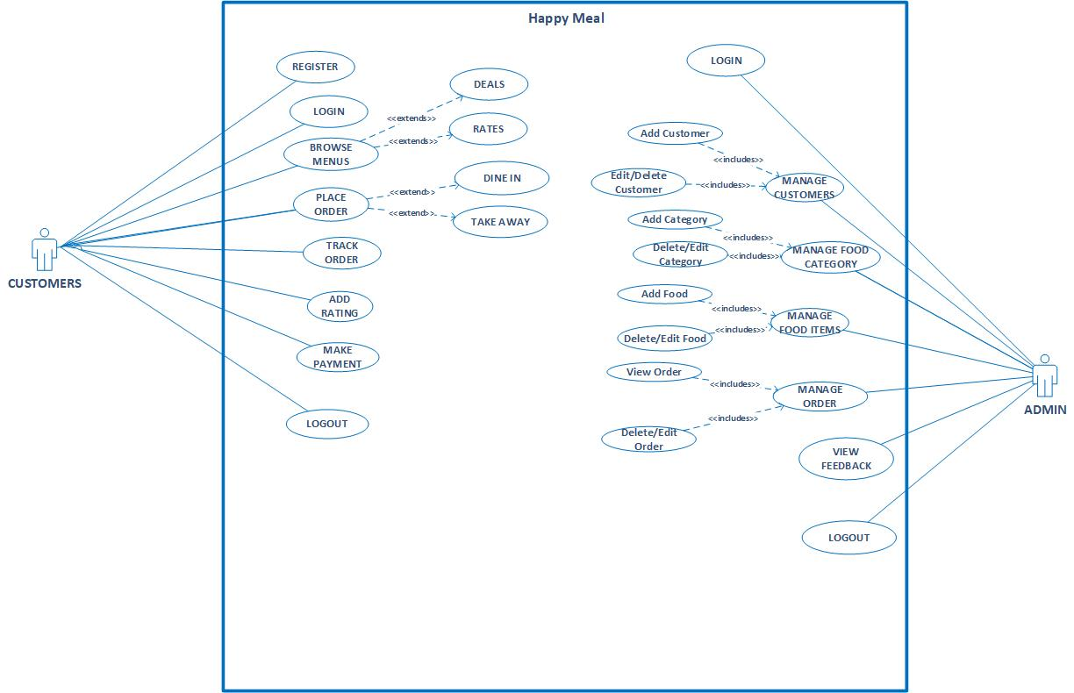
Use Case Diagram(s):

USAGE SCENARIOS:
REGISTER:

Use Case id | 1
Use Case title | REGISTER
Description | All users who wants to order food must have to create an account.
Pre-condition | Application interface must be available.
Action | - Open application interface of create account  - Fill the form of registration  - Click on “Register” button to get registered
Post Conditions | User successfully created in database.
Alternative Path: | User may not want to register this time
Exception: | If the user entered invalid data in the form then the exception occurs “Fill mandatory Fields”
Authority | Customer,
Author | Bc200405761 (Eman Batool)

LOGIN:

Use Case id | 2
Use Case title | LOGIN
Description | All users going to login to the application.
Pre-condition | User must be created first , Application interface must be available
Action | - Open application interface of login  - Enter user name and password  - Click on “Login” button
Post Conditions | User successfully login and able to further work
Alternative Path: | User may not want to login this time
Exception: | If the user entered invalid data in the form then the exception occurs “Invalid user name and password”
Authority | Customer, Admin
Author | Bc200405761 (Eman Batool)

BROWSE MENU:

Use Case id | 3
Use Case title | BROWSE MENU
Description | This use case allows registered Customers to view/search the desired food item that are available in our system
Pre-condition | User must be registered and Application interface must be available
Action | - Open application interface and fill the criteria of browse menu items.  - Click on the “View Menus” button
Post Conditions | All items that fall on the search criteria will be displayed on the website
Alternative Path: | Customers may not want to browse menu this time
Exception: | If none of the items in the inventory meets the search criteria no item will be displayed.
Authority | Customers
Author | Bc200405761 (Eman Batool)

PLACE ORDER

Use Case id | 4
Use Case title | PLACE ORDER
Description | This use case allows customers to order their desired food anytime.
Pre-condition | The application interface must be available. The customer must be Logged in
Action | - Open application interface.  - Select the desired items.  - Click on the place order button.
Post Conditions | Order will be placed.
Alternative Path: | Customers may not want to place order this time.
Exception: | If a customer is not logged in this feature is not available
Authority | Customers
Author | Bc200405761 (Eman Batool)

TRACK ORDER

Use Case id | 5
Use Case title | TRACK ORDER
Description | This use case allows customers to track their ordered food anytime.
Pre-condition | The application interface must be available. The customer must be Logged in
Action | - Open application interface.  - Select the view my orders tab.  - All orders placed by you will be available.
Post Conditions | Order details will be available to customer.
Alternative Path: | Customers may not want to track order this time.
Exception: | If a customer is not logged in this feature is not available
Authority | Customers
Author | Bc200405761 (Eman Batool)

ADD RATING:

Use Case id | 6
Use Case title | ADD RATING
Description | This use case allows Customers to add rating about products available on website.
Pre-condition | The customer must be registered and logged in to the system.
Action | - Open application interface and login by providing valid username and password  - Select desired food item  - Add your rating using stars  - Click on the add rating button of desired Food item
Post Conditions | Rating of particular food item has been added to the system.
Alternative Path: | Customer may not want to add rating this time
Exception: | -
Authority | Customers
Author | Bc200405761 (Eman Batool)

MANAGE CUSTOMERS

Use Case id | 7
Use Case title | MANAGE CUSTOMERS
Description | This use case is about managing customers registered on this website.
Pre-condition | - Admin users must be logged in.  - The database should be available on the computer.
Action | - Open application interface.  - Click on manage customers tab.  - Click on desired function(Add, Edit/ Delete Customers)
Post Conditions | Customers will be updated in database and updated details will be available on website as well
Alternative Path: | Admin may not want to manage customers this time.
Exception: | If the user is not Admin this feature is not available
Authority | Admin
Author | Bc200405761 (Eman Batool)

MANAGE CATEGORY

Use Case id | 8
Use Case title | MANAGE CATEGORY
Description | This use case is about add/edit/delete categories available on your website.
Pre-condition | - Admin users must be logged in.  - The database should be available on the computer.
Action | - Open application interface.  - Click on manage items tab.  - Click on desired function(Add, Edit/ Delete Categories)
Post Conditions | Categories will be updated in database and updated details will be available on website as well
Alternative Path: | Admin may not want to manage Categories this time.
Exception: | If the user is not Admin this feature is not available
Authority | Admin
Author | Bc200405761 (Eman Batool)

MANAGE FOOD ITEMS

Use Case id | 9
Use Case title | MANAGE FOOD ITEMS
Description | This use case is about add/edit/delete food items available on website.
Pre-condition | - Admin users must be logged in.  - The database should be available on the computer.
Action | - Open application interface.  - Click on manage items tab.  - Click on desired function(Add, Edit/ Delete Item)
Post Conditions | Items will be updated in database and updated details will be available on website as well
Alternative Path: | Admin may not want to manage items this time.
Exception: | If the user is not Admin this feature is not available
Authority | Admin
Author | Bc200405761 (Eman Batool)

MANAGE ORDER

Use Case id | 10
Use Case title | MANAGE ORDER
Description | This use case is about add/edit/delete orders placed by user.
Pre-condition | - Admin users must be logged in.  - The database should be available on the computer.
Action | - Open application interface.  - Click on manage order tab.  - Click on desired function (Add, Edit/ Delete Order)
Post Conditions | Items will be updated in database and updated details will be available on website as well
Alternative Path: | Admin may not want to manage orders this time.
Exception: | If the user is not Admin this feature is not available
Authority | Admin
Author | Bc200405761 (Eman Batool)

VIEW FEEDBACK

Use Case id | 11
Use Case title | VIEW FEEDBACK
Description | This use case is about viewing feedback of food items that were given by customers of the system.
Pre-condition | - Admin users must be logged in  - Database should be available on the computer.
Action | - Open application interface.  - Click on view feedback Button
Post Conditions | Details of feedback Added by customers is available.
Alternative Path: | Admin may not want to view feedback this time.
Exception: | If the user is not Admin in this feature is not available
Authority | Admin
Author | Bc200405761 (Eman Batool)

LOGOUT

Use Case id | 12
Use Case title | LOGOUT
Description | This use case allows all the actors of the system to logout from website.
Pre-condition | The application interface must be available and any of the actor must be Logged in.
Action | - Open application interface.  - Click on Logout Button.
Post Conditions | Session is destroyed and actor will be logout from system.
Alternative Path: | Force close website.
Exception: | If session is empty than this feature is not available.
Authority | Admin,Customer
Author | Bc200405761 (Eman Batool)

Adopted Methodology
Development of any software product or application choice of right model is very important. The selection of model has very high impact on the testing that is carried out. It will define that what, where and when of our planned testing, influence regression testing and which test techniques to use. The development models are the various processes or methodologies that are being selected for the development of the project depending on the project aims and goals. There are many development life cycle models that have been developed in order to achieve different required objectives. The models specify the various stages of the process and the order in which they are carried out There are various Software development models or methodologies we discus Water Fall and Spiral Model in the following.

Waterfall Model:
The waterfall Model is a linear sequential flow. In which progress is seen as flowing steadily downwards (like a waterfall) through the phases of software implementation. This means that any phase in the development process begins only if the previous phase is complete. The waterfall approach does not define the process to go back to the previous phase to handle changes in requirement. The waterfall approach is the earliest approach that was used for software development.
Diagram
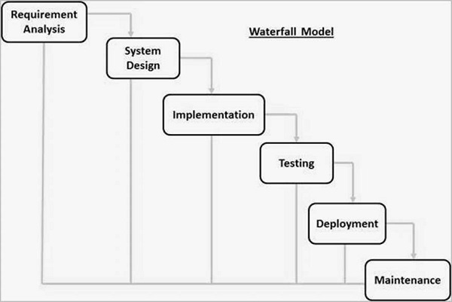
Spiral Model:
The spiral model is similar to the incremental model, with more emphasis placed on risk analysis. The spiral model has four phases: Planning, Risk Analysis, Engineering and Evaluation. A software project repeatedly passes through these phases in iterations (called Spirals in this model). The baseline spiral, starting in the planning phase, requirements are gathered and risk is assessed. Each subsequent spirals builds on the baseline spiral.
Planning Phase:
Requirements are gathered during the planning phase.
Risk Analysis:
A prototype is produced at the end of the risk analysis phase. If any risk is found during the risk analysis, then alternate solutions are suggested and implemented.
Engineering Phase:
In this phase software is developed, along with testing at the end of the phase. In this phase the development and testing is done.
Evaluation phase:
This phase allows the customer to evaluate the output of the project to date before the project continues to the next spiral.
Diagram of Spiral model:
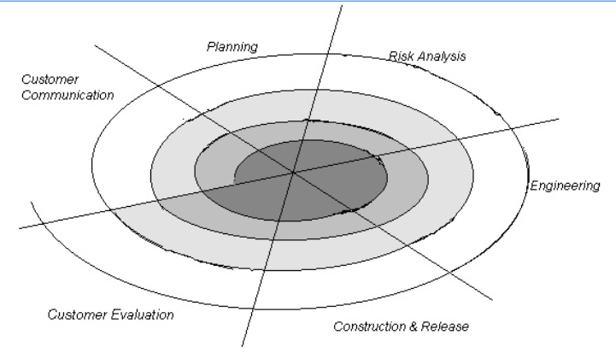
VU Process Model:
The methodology chosen for this project is VU Process Model. The vu process model, offers numerous advantages for software developers and because of its beneficial flow I use this methodology. This model is a combination of Waterfall and Coiled/Spiral Model. This is a hybrid approach of system development, which maximizes the quality of system and minimizes the disadvantages and risks.
VU process model has four phases; each phase is tested on its completion. It
conserves resources and is superlative for sustaining less skilled plan teams and project managers whose composition fluctuates. The errors are removed due to iteration to previous or next phases. The orderly sequence of development steps and strict controls for ensuring the adequacy of documentation and design reviews helps ensure the quality, reliability, and maintainability of the developed software. The progress of system development is measurable.VU Process model depicts the linear nature of waterfall and iterative risk analysis of spiral. We analyze each phase activity with the end product. VU Process model will help us in identification of risk at the time as it omits. So resolution of that risk will be much easy at that point, while if it is detected at later stage then the resolution will become much more painful and costly (time& budget). Also documentation makes the maintenance of product after its delivery easy. So by combining the spiral & waterfall we get the benefits of waterfall and risk sensitivity of the spiral.
REASONS FOR CHOOSING THE METHODOLOGY
- The Waterfall Model is a documentation-driven model. It therefore generates complete and comprehensive documentation and hence makes the maintenance task much easier. Documentation helps to keep track to risk.

- It suggests a systematic, sequential approach to software development that begins at the system level and progresses through the analysis, design, coding, testing, and maintenance.
Vu Process Model Diagram;
Analyzing & Gathering requirement

Planning Phase

Analysis & Design Phase

Development Phase

Operation & Maintenance
Analysis and Design Phase
Development Phase
Operation & Maintenance

Work Plan (Use MS Project to create Schedule/Work Plan)

SRS AND DESIGN DOCUMENT
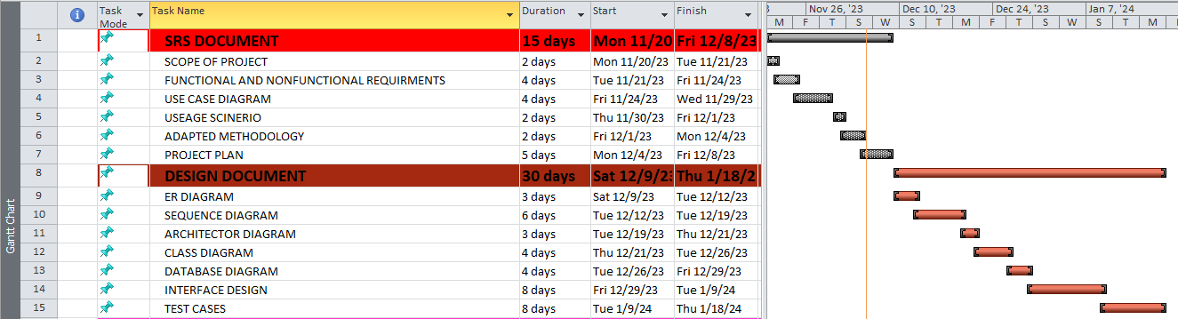

TESTPHASE AND FINAL DELIVERABLES

